Ответы:

$y=C_{1}e^{-3x}+C_{2}e^{-2x}-\frac{53}{52}\sin{2x}+\frac{31}{52}\cos{2x}$

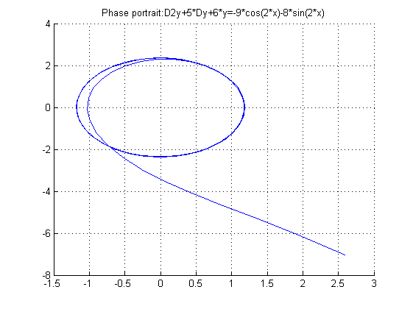 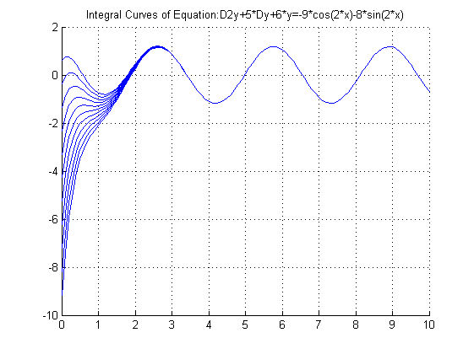

$y=C_{1}e^{-2x}+C_{2}e^{-x}-\frac{3}{170}\sin{4x+\frac{7}{340}\cos{4x+\frac{1}{4}}}$

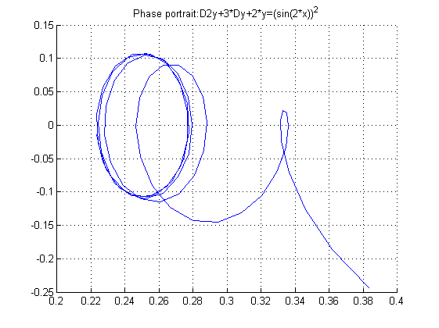 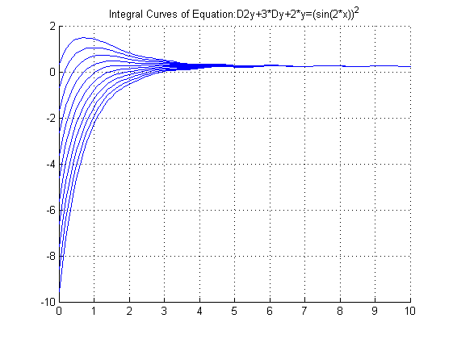

$y=C_{1}e^{-3x}+C_{2}e^{-x}+6e^{-2x}+\frac{3}{5}\sin{x}-\frac{6}{5}\cos{x}$

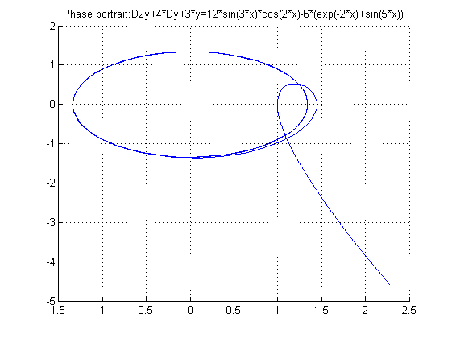 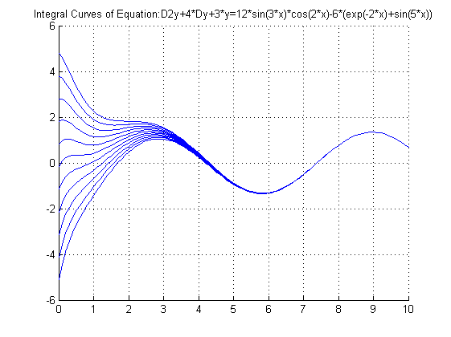

$y=C_{1}e^{-4x}+C_{2}e^{-x}+\frac{2}{17}\sin{x}+\frac{8}{17}\cos{x}$

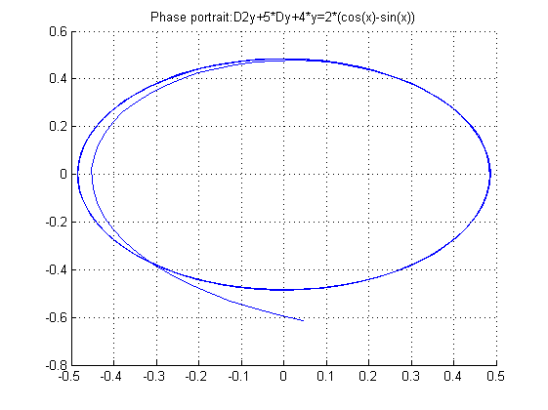 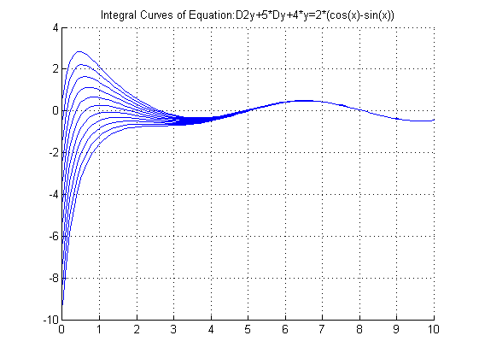

$y=C_{1}e^{-5x}+C_{2}e^{-x}+\frac{3}{26}x^{2}\sin{x}+\frac{1}{13}x^{2}\cos{x}-\frac{93}{169}x\sin{x}+\frac{1544}{2197}\sin{x}--\frac{88}{169}x\cos{x}-\frac{80}{2197}\cos{x}$

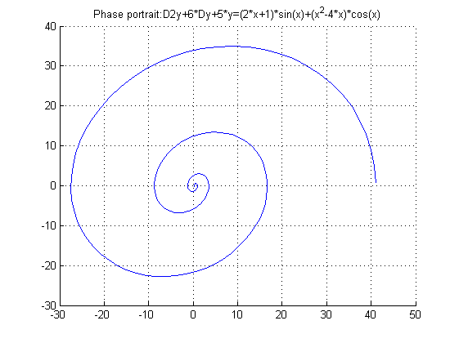 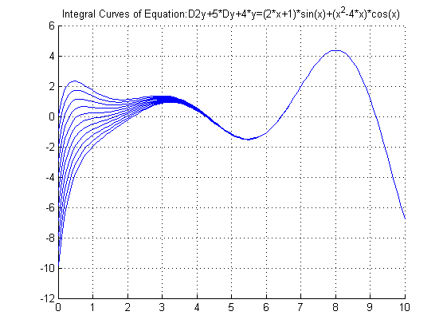

$y=C_{1}e^{-4x}+C_{2}e^{-2x}-\frac{1}{5}x\sin{2x}+\frac{3}{100}\sin{2x}+\frac{3}{5}x\cos{2x}-\frac{29}{100}\cos{2x}$

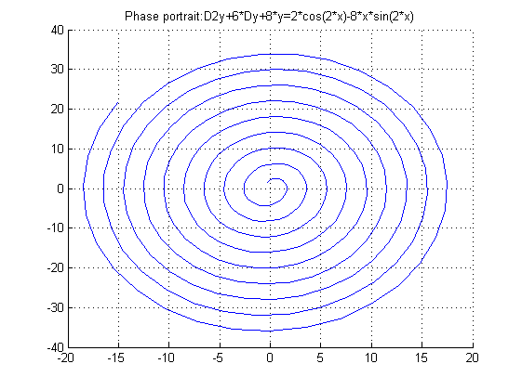 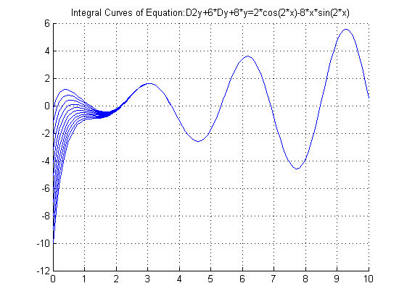

$y=C_{1}xe^{-x}+C_{2}e^{-x}+\frac{1}{6}e^{-x}x^{3}-\frac{1}{2}x\sin{x}+\frac{1}{2}\sin{x}-\frac{1}{2}\cos{x}$

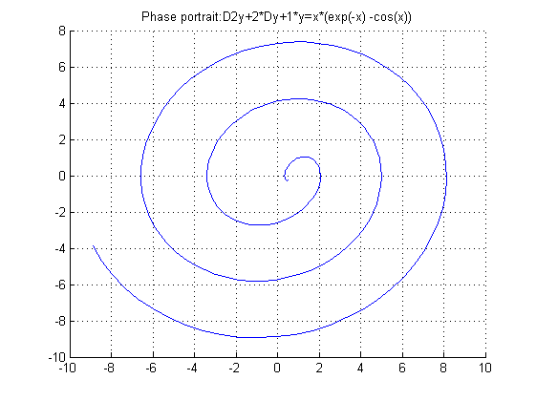 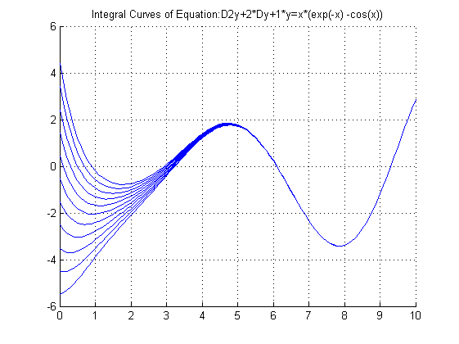

$y=C_{1}e^{-2x}+C_{2}xe^{-2x}+\frac{4}{25}x\sin{x}-\frac{22}{125}\sin{x}+\frac{3}{25}x\cos{x}-\frac{4}{125}\cos{x}$

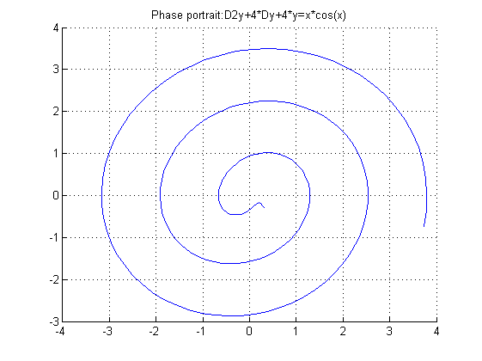 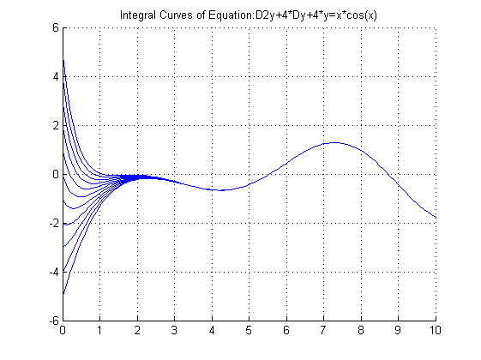

$y=C_{1}e^{-3x}+C_{2}xe^{-3x}+\frac{27}{169}\sin{2x}-\frac{31}{169}\cos{2x}$

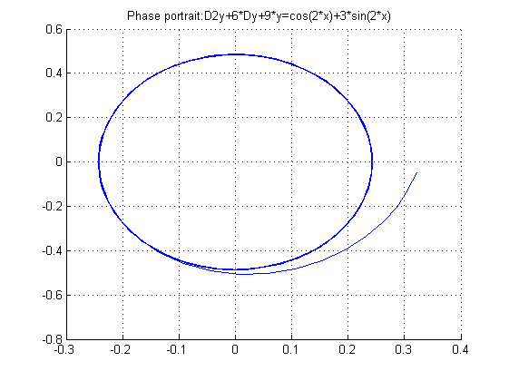 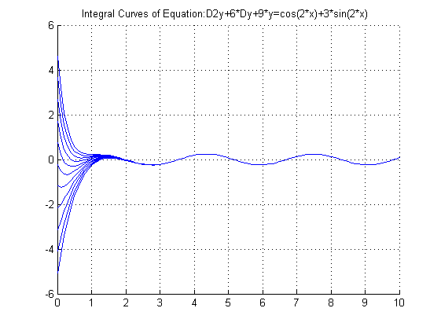

$y=C_{1}e^{-5x}+C_{2}xe^{-5x}+\frac{10}{169}x\sin{x}+\frac{82}{2197}\sin{x}+\frac{24}{169}x\cos{x}-\frac{175}{2197}\cos{x}$

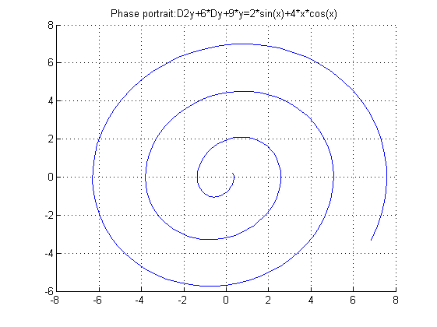 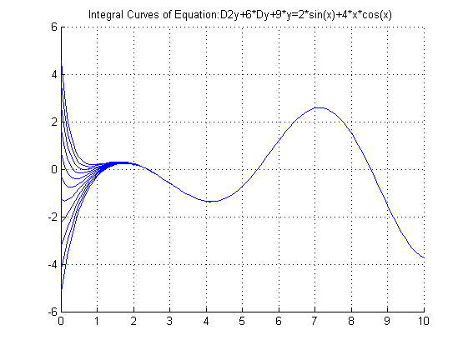

$y=C_{1}cos\left(\sqrt{2}x\right)+C_{2}sin\left(\sqrt{2}x\right)-\frac{1}{2}\cos{2x}-\frac{1}{7}\cos{4x}+\frac{3}{2}$

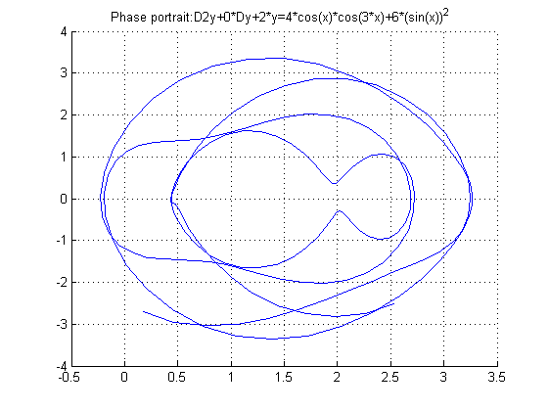 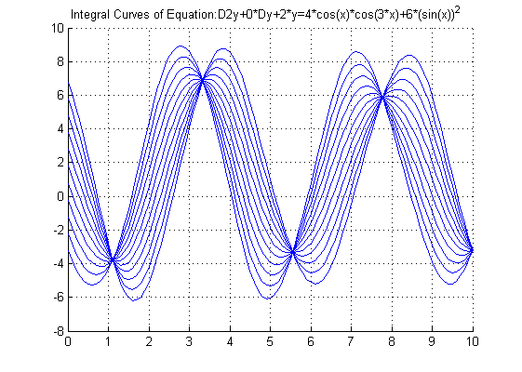

$y=C_{1}cos\left(2x\right)+C_{2}sin\left(2x\right)+x\left(\sin{2x}-\cos{2x}\right)$

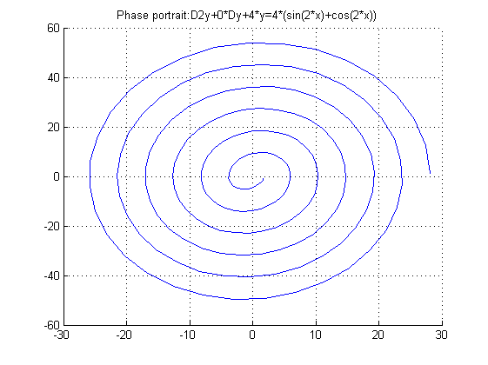 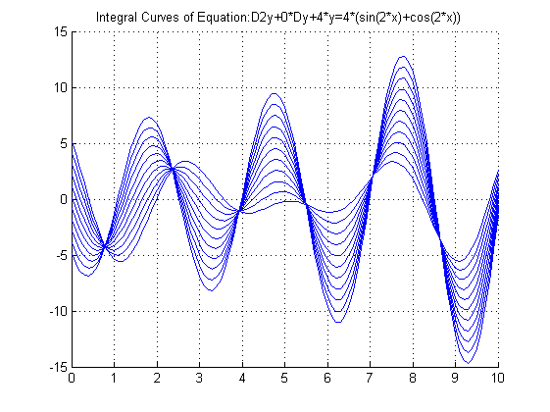

$y=C_{1}cos\left(2x\right)+C_{2}sin\left(2x\right)+\frac{1}{8}x\sin{2x}+\frac{1}{4}\cos^{2}{x}$

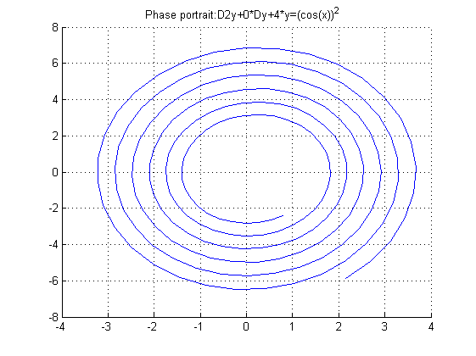 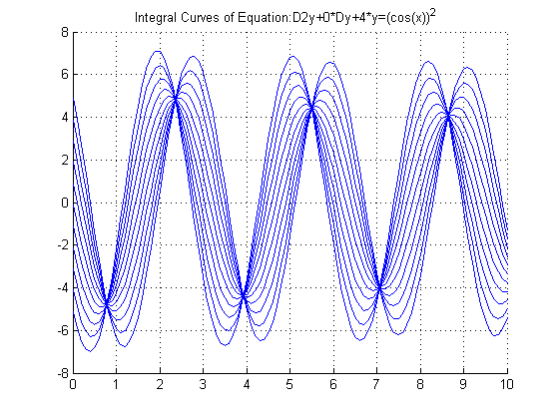

$y=C_{1}cos\left(4x\right)+C_{2}sin\left(4x\right)+\frac{1}{6}\cos^{4}{2x}$

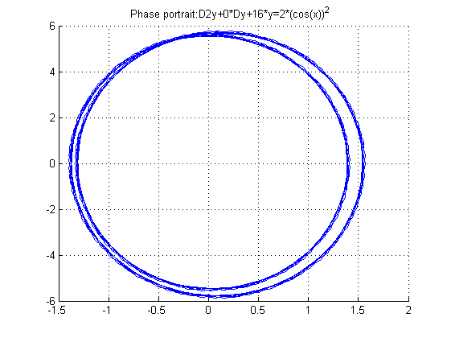 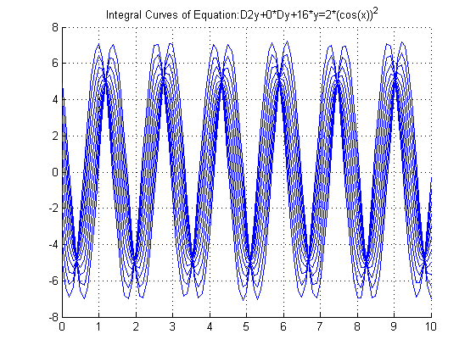

$y=C_{1}cos\left(2x\right)+C_{2}sin\left(2x\right)-x\cos{2x}$

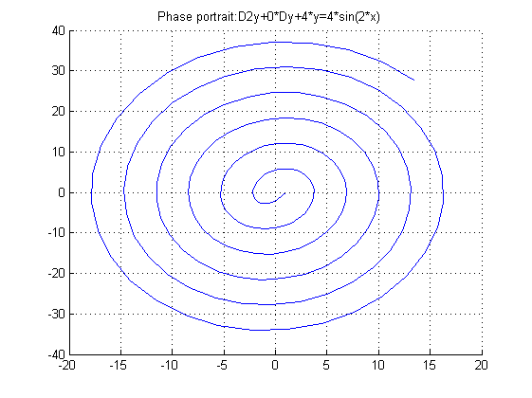 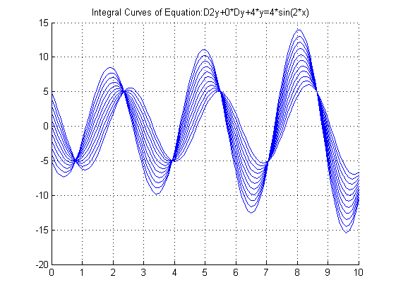

$y=C_{1}cos\left(x\right)+C_{2}sin\left(x\right)+\frac{1}{3}\sin{2x}-\frac{2}{15}\sin{2x}\cos{2x}$

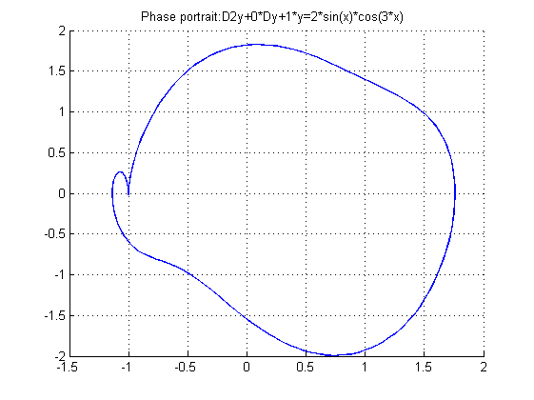 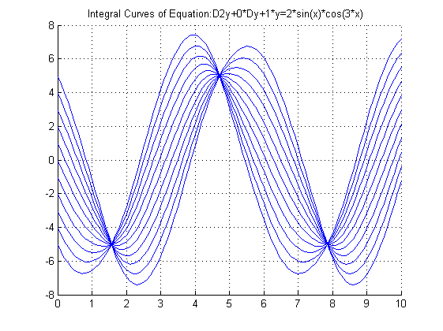

$y=C_{1}cos\left(3x\right)+C_{2}sin\left(3x\right)+\frac{1}{9}x-\frac{2}{3}x\cos{3x}$

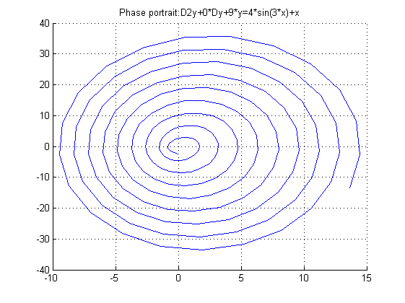 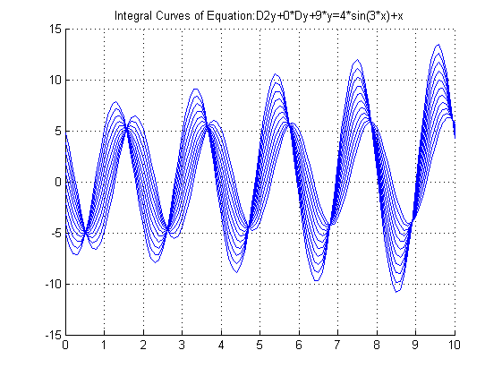

$y=C_{1}cos\left(x\right)+C_{2}sin\left(x\right)-4e^{-x}-2x\cos{x}+1$

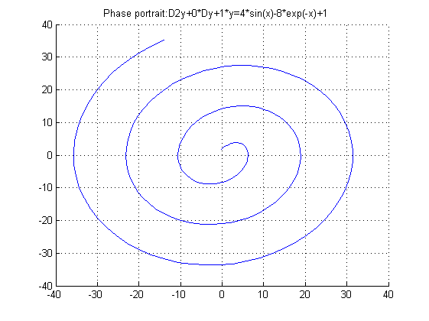 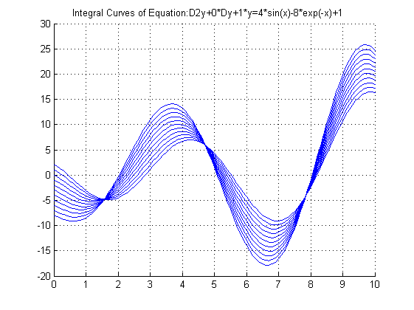

$y=C_{1}e^{-x}cos\left(2x\right)+C_{2}e^{-x}sin\left(2x\right)+e^{-x}+\sin{2x}-4\cos{2x}$

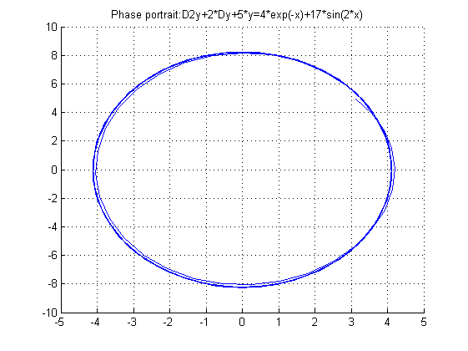 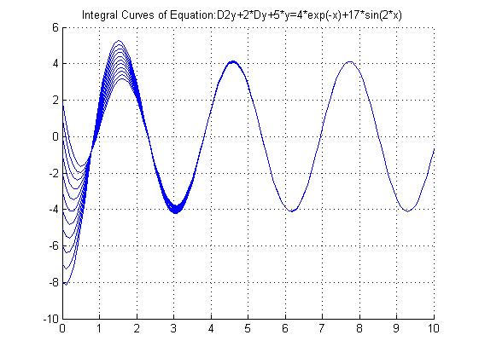

$y=C_{1}e^{-\frac{x}{2}}\sin{\frac{\sqrt{3} x}{2}}+C_{2}e^{-\frac{x}{2}}\cos{\frac{\sqrt{3} x}{2}}+\sin{x}-\frac{3}{13}\cos{2x}+\frac{2}{13}\sin{2x}$

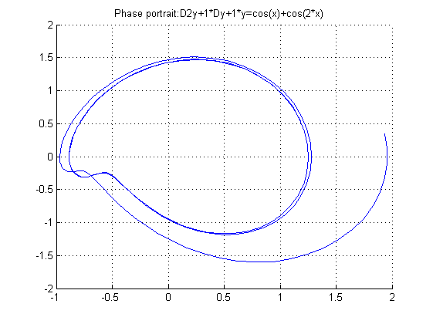 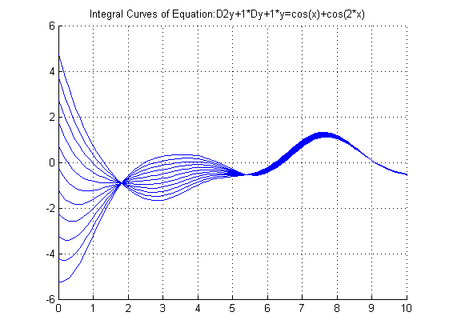

Скрипт для нахождения решения уравнения, построения фазового портрета и интегральных кривых:

clf;

syms x y dy InHequation x_new y_new dy_new y_temp dy_temp cycle;

InHequation = 'D2y+4*Dy+4*y=x*cos(x)';

y = simplify(dsolve(InHequation, 'x'));

Title=['Phase portrait:',char(InHequation)];

grid on;

hold on;

disp(y);

dy=diff(y,'x');

for cycle = 0 : 0.05 : 10

y_temp = subs(y, 'C52', 1);

dy_temp = subs(dy, 'C52', 1);

y_temp = subs(y_temp, 'C53', 1);

dy_temp = subs(dy_temp, 'C53', 1);

if(abs(double(subs(y_temp, 'x', cycle)))>10||abs(double(subs(dy_temp, 'x', cycle)))>10)

break;

end;

end;

x_new=1:0.1:cycle;

y_new=subs(y_temp, 'x', x_new);

dy_new=subs(dy_temp, 'x', x_new);

plot(y_new, dy_new);

title(char(Title));

figure;

grid on;

hold on;

Title=['Integral Curves of Equation:',char(InHequation)];

x_new=0:0.1:10;

for cycle1=-5:1:5

val=cycle1;

y_new=subs(y,'C52',val);

for cycle2=-5:1:5

val=cycle2;

y_new=subs(y_new,'C53',val);

y_new=real(double(subs(y_new,x_new)));

plot(x_new,y_new);

end;

end;

title(char(Title));

Скрипт для нахождения решения уравнения методом Коши:

syms p;

A=[0 1;-6 5];

t0=0;

Y=[1;1];

func=[0;13*sin(3*p)];

syms lambda t temp x1 x2;

ASymb=sym(A);

for i=1:1:2

ASymb(i,i)=ASymb(i,i)-lambda;

end;

self_v=solve(det(ASymb));

E=[1 0;0 1];

Zmatr=[0;0];

Equsystem1=A-self_v(1)*E;

X1=Equsystem1\Zmatr;

if(det(Equsystem1)==0)

X1(1)=1; X1(2)=double(-Equsystem1(1,1)/Equsystem1(1,2));

end;

Equsystem2=A-self_v(2)*E;

X2=Equsystem2\Zmatr;

if(det(Equsystem2)==0)

X2(1)=1; X2(2)=double(-Equsystem2(1,1)/Equsystem2(1,2));

end;

Ft=sym(zeros(2));

Ft(:,1)=X1*exp(self_v(1)*t);

Ft(:,2)=X2*exp(self_v(2)*t);

Ft=simplify(Ft);

if(det(Ft)==0)

disp('Incorrect values');

else

invft=inv(Ft);

disp('Y(t) =');

right=Ft*subs(invft,'t',t0)*Y;

left=Ft*int(subs(invft,'t','p')*func,p,t0,t);

disp(right+left);

end;